Using this script in place of user name & password for Docker login.

Tools

Java

Sonar Cube scanner

Maven

Sonar Server

**//Jenkins Pipe line script//**

pipeline {

agent any

tools {

maven 'maven-rishi'

jdk 'jdk17-rishi'

// Remove the sonarQube line if it still causes issues

}

environment {

SCANNER_HOME = tool 'sonar-scanner-rishi'

DOCKERHUB_USERNAME = 'rrishi914' // Set this directly to your Docker Hub username

DOCKER_IMAGE = "${DOCKERHUB_USERNAME}/spotify-app-rishi:latest"

}

stages {

stage('Git Checkout') {

steps {

git branch: 'main', url: 'https://github.com/rishi914-max/Sonar-Qube.git'

}

}

stage('Compile') {

steps {

sh "mvn compile"

}

}

stage('Test') {

steps {

sh "mvn test"

}

}

stage('Sonar Analysis') {

steps {

withSonarQubeEnv('sonar-server-rishi') {

sh "$SCANNER_HOME/bin/**sonar-scanner** -Dsonar.projectName=Rishi -Dsonar.projectKey=RishiKey -Dsonar.java.binaries=target"

}

}

}

stage('Build') {

steps {

sh "mvn package"

}

}

stage('Docker Build') {

steps {

script {

// Building Docker Image

sh "docker build -t $DOCKER_IMAGE ."

}

}

}

stage('Docker Push to DockerHub') {

steps {

script {

withCredentials([string(credentialsId: 'rrishi914', variable: 'DOCKERHUB_TOKEN')]) {

echo "Docker Image: ${DOCKER_IMAGE}" // Just to verify image name

sh '''

echo "$DOCKERHUB_TOKEN" | docker login -u "rrishi914" --password-stdin

docker push "$DOCKER_IMAGE"

'''

}

}

}

}

stage('Run Docker Container') {

steps {

script {

// Stop any existing container with the same name

sh "docker stop spotify-app || true && docker rm spotify-app || true"

// Running the container

sh "docker run -d --name spotify-app -p 8888:8888 $DOCKER_IMAGE"

}

}

}

}

post {

always {

echo 'Cleaning up workspace...'

cleanWs() // Clean up the workspace after the build

}

}

}

**//Docker File//**

FROM openjdk:17-jdk-slim

WORKDIR /app

COPY target/spotify-app-1.0.0.jar /app/spotify-app.jar

EXPOSE 8888

ENTRYPOINT ["java", "-jar", "spotify-app.jar"]

Git Repo URL : https://github.com/rishi914-max/Sonar-Qube.git

**Sonar Cube Dashboard**

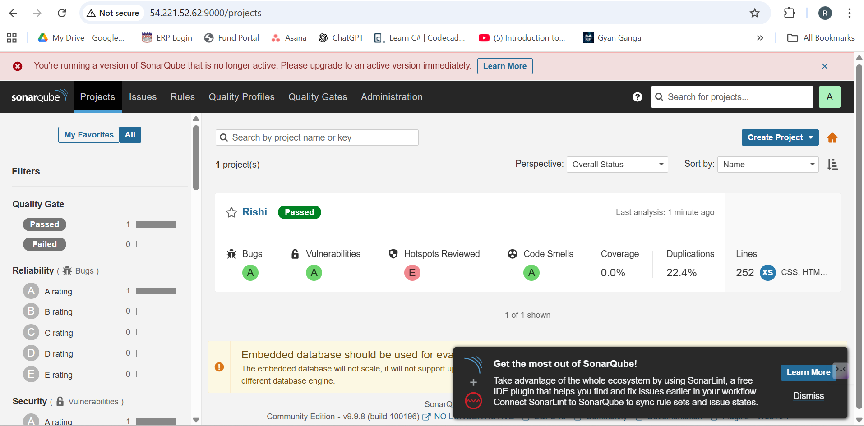

**Docker Hub Dashboard**

